LAPORAN UJIAN AKHIR SEMESTER PRATIKUM MOBIL COMPUTING II



Disusun Oleh :
- Fiki agus setiawan 120403020002
- Dana agus setiawan 120403020008
- Rino ika rama andika 120403020009

PROGRAM STUDI TEKNOLOGI INFORMASI
FAKULTAS SAINT DAN TEKNOLOGI
UNIVERSITAS KANJURUHAN MALANG
2016
Langkah langkah dalam membuat projeck android pegawai
- Buatlah skrip php pegawai di notepad
Pegawai.php

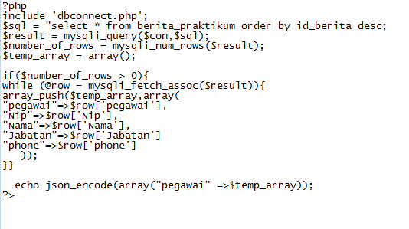

- Tambahkan Data pegawai
Add.pegawai.php

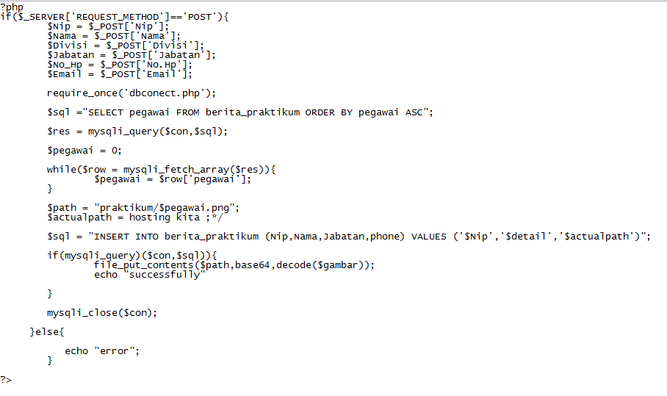

- Buat skrip koneksi ke database
Db.connect.php

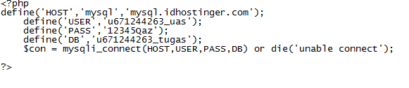
- Hasil jsonnya
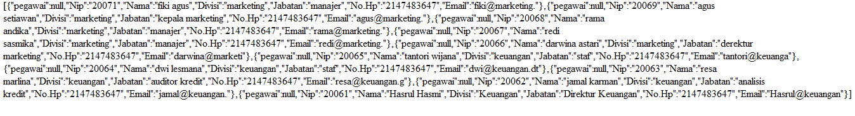
- Lalu bukalah android studio
- Buat layout untuk pegawai

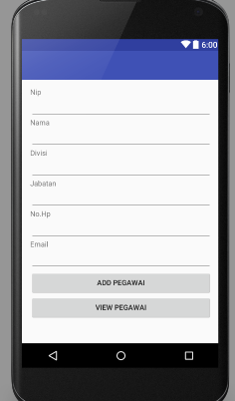

Skripnya dibawah ini

Activity_main.xml
<LinearLayout xmlns:android="http://schemas.android.com/apk/res/android"
xmlns:tools="http://schemas.android.com/tools" android:layout_width="match_parent"
android:orientation="vertical"
android:layout_height="match_parent" android:paddingLeft="@dimen/activity_horizontal_margin"
android:paddingRight="@dimen/activity_horizontal_margin"
android:paddingTop="@dimen/activity_vertical_margin"
android:paddingBottom="@dimen/activity_vertical_margin" tools:context=".MainActivity">
<TextView
android:layout_width="wrap_content"
android:layout_height="wrap_content"
android:text="Nip" />
<EditText
android:layout_width="match_parent"
android:layout_height="wrap_content"
android:id="@+id/editTextNip" />
<TextView
android:layout_width="wrap_content"
android:layout_height="wrap_content"
android:text="Nama" />
<EditText
android:layout_width="match_parent"
android:layout_height="wrap_content"
android:id="@+id/editTextNama" />
<TextView
android:layout_width="wrap_content"
android:layout_height="wrap_content"
android:text="Divisi" />
<EditText
android:layout_width="match_parent"
android:layout_height="wrap_content"
android:id="@+id/editTextDivisi" />
<TextView
android:layout_width="wrap_content"
android:layout_height="wrap_content"
android:text="Jabatan" />
<EditText
android:layout_width="match_parent"
android:layout_height="wrap_content"
android:id="@+id/editTextJabatan" />
<TextView
android:layout_width="wrap_content"
android:layout_height="wrap_content"
android:text="No.Hp" />
<EditText
android:layout_width="match_parent"
android:layout_height="wrap_content"
android:id="@+id/editTextNo.Hp" />
<TextView
android:layout_width="wrap_content"
android:layout_height="wrap_content"
android:text="Email" />
<EditText
android:layout_width="match_parent"
android:layout_height="wrap_content"
android:id="@+id/editTextEmail" />
<Button
android:layout_width="match_parent"
android:layout_height="wrap_content"
android:text="Add Pegawai"
android:id="@+id/buttonAdd" />
<Button
android:layout_width="match_parent"
android:layout_height="wrap_content"
android:text="View Pegawai"
android:id="@+id/buttonView" />
</LinearLayout>

- Selanjutnya buat tampilan listview

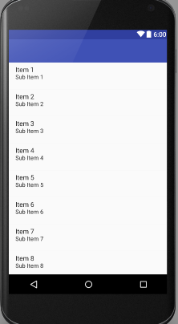

Skripnya seperti dibawah ini

Listview.xml
<?xml version="1.0" encoding="utf-8"?>
<LinearLayout xmlns:android="http://schemas.android.com/apk/res/android"
android:orientation="vertical" android:layout_width="match_parent"
android:layout_height="match_parent">
<ListView
android:layout_width="match_parent"
android:layout_height="wrap_content"
android:id="@+id/listView" />
</LinearLayout>

- Membuat update dan delete
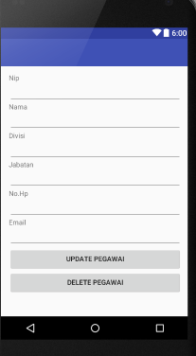

Viewpegawai.xml
<LinearLayout xmlns:android="http://schemas.android.com/apk/res/android"
xmlns:tools="http://schemas.android.com/tools" android:layout_width="match_parent"
android:orientation="vertical"
android:layout_height="match_parent" android:paddingLeft="@dimen/activity_horizontal_margin"
android:paddingRight="@dimen/activity_horizontal_margin"
android:paddingTop="@dimen/activity_vertical_margin"
android:paddingBottom="@dimen/activity_vertical_margin" tools:context=".MainActivity">
<TextView
android:layout_width="wrap_content"
android:layout_height="wrap_content"
android:text="Nip" />
<EditText
android:layout_width="match_parent"
android:layout_height="wrap_content"
android:id="@+id/editTextNip" />
<TextView
android:layout_width="wrap_content"
android:layout_height="wrap_content"
android:text="Nama" />
<EditText
android:layout_width="match_parent"
android:layout_height="wrap_content"
android:id="@+id/editTextNama" />
<TextView
android:layout_width="wrap_content"
android:layout_height="wrap_content"
android:text="Divisi" />
<EditText
android:layout_width="match_parent"
android:layout_height="wrap_content"
android:id="@+id/editTextDivisi" />
<TextView
android:layout_width="wrap_content"
android:layout_height="wrap_content"
android:text="Jabatan" />
<EditText
android:layout_width="match_parent"
android:layout_height="wrap_content"
android:id="@+id/editTextJabatan" />
<TextView
android:layout_width="wrap_content"
android:layout_height="wrap_content"
android:text="No.Hp" />
<EditText
android:layout_width="match_parent"
android:layout_height="wrap_content"
android:id="@+id/editTextNo.Hp" />
<TextView
android:layout_width="wrap_content"
android:layout_height="wrap_content"
android:text="Email" />
<EditText
android:layout_width="match_parent"
android:layout_height="wrap_content"
android:id="@+id/editTextEmail" />
<Button
android:layout_width="match_parent"
android:layout_height="wrap_content"
android:text="Update Pegawai"
android:id="@+id/buttonUpdate" />
<Button
android:layout_width="match_parent"
android:layout_height="wrap_content"
android:text="Delete Pegawai"
android:id="@+id/buttonDelete" />
</LinearLayout>
- Membuat list_item
List_item.xml
<?xml version="1.0" encoding="utf-8"?>
<LinearLayout xmlns:android="http://schemas.android.com/apk/res/android"
android:orientation="vertical" android:layout_width="match_parent"
android:layout_height="match_parent">
<TextView
android:id="@+id/nip"
android:layout_width="wrap_content"
android:layout_height="wrap_content" />
<TextView
android:id="@+id/nama"
android:layout_width="wrap_content"
android:layout_height="wrap_content" />
<TextView
android:id="@+id/divisi"
android:layout_width="wrap_content"
android:layout_height="wrap_content" />
<TextView
android:id="@+id/jabatan"
android:layout_width="wrap_content"
android:layout_height="wrap_content" />
<TextView
android:id="@+id/no.hp"
android:layout_width="wrap_content"
android:layout_height="wrap_content" />
<TextView
android:id="@+id/email"
android:layout_width="wrap_content"
android:layout_height="wrap_content" />
</LinearLayout>

- Selanjutnya membuat java
Config.java
package com.example.asus.uasmobile;
public class Config {
public static final String URL_ADD="http://192.168.94.1/Android/CRUD/add_pegawai.php";
public static final String URL_GET_ALL = "http://192.168.94.1/Android/CRUD/getallpegawai.php";
public static final String URL_GET_PEG = "http://192.168.94.1/Android/CRUD/pegawai.php?id=";
public static final String URL_UPDATE_PEG = "http://192.168.94.1/Android/CRUD/updatepegawai.php";
public static final String URL_DELETE_PEG = "http://192.168.94.1/Android/CRUD/deletepegawai.php?id=";
public static final String KEY_PEG_NIP = "nip";
public static final String KEY_PEG_NAMA = "nama";
public static final String KEY_PEG_DIVISI = "divisi";
public static final String KEY_PEG_JABATAN = "jabatan";
public static final String KEY_PEG_NO_HP = "no.hp";
public static final String KEY_PEG_EMAIL = "email";
public static final String TAG_JSON_ARRAY="result";
public static final String TAG_NIP = "nip";
public static final String TAG_NAMA = "nama";
public static final String TAG_DIVISI = "divisi";
public static final String TAG_JABATAN = "jabatan";
public static final String TAG_NO_HP = "no.hp";
public static final String TAG_EMAIL = "email";
public static final String PEG_NIP = "peg_nip";
}

Activity_main.java
package com.example.asus.uasmobile;
import android.app.ProgressDialog;
import android.content.Intent;
import android.os.AsyncTask;
import android.support.v7.app.AppCompatActivity;
import android.os.Bundle;
import android.view.Menu;
import android.view.MenuItem;
import android.view.View;
import android.widget.Button;
import android.widget.EditText;
import android.widget.Toast;
import java.util.HashMap;
public class MainActivity extends AppCompatActivity implements View.OnClickListener{
//Defining views
private EditText editTextNip;
private EditText editTextNama;
private EditText editTextDivisi;
private EditText editTextJabatan;
private EditText editTextNo_Hp;
private EditText editTextEmail;
private Button buttonAdd;
private Button buttonView;
@Override
protected void onCreate(Bundle savedInstanceState) {
super.onCreate(savedInstanceState);
setContentView(R.layout.activity_main);
//Initializing views
editTextNip = (EditText) findViewById(R.id.editTextNip);
editTextNama = (EditText) findViewById(R.id.editTextNama);
editTextDivisi = (EditText) findViewById(R.id.editTextDivisi);
editTextJabatan = (EditText) findViewById(R.id.editTextJabatan);
editTextNo_Hp = (EditText) findViewById(R.id.editTextNo_Hp);
editTextEmail = (EditText) findViewById(R.id.editTextEmail);
buttonAdd = (Button) findViewById(R.id.buttonAdd);
buttonView = (Button) findViewById(R.id.buttonView);
//Setting listeners to button
buttonAdd.setOnClickListener(this);
buttonView.setOnClickListener(this);
}
//Adding an employee
private void addPegawai(){
final String nip = editTextNip.getText().toString().trim();
final String nama = editTextNama.getText().toString().trim();
final String divisi = editTextDivisi.getText().toString().trim();
final String jabatan = editTextJabatan.getText().toString().trim();
final String no_hp = editTextNo_Hp.getText().toString().trim();
final String email = editTextEmail.getText().toString().trim();
class addPegawai extends AsyncTask<Void,Void,String>{
ProgressDialog loading;
@Override
protected void onPreExecute() {
super.onPreExecute();
loading = ProgressDialog.show(MainActivity.this,"Adding...","Wait...",false,false);
}
@Override
protected void onPostExecute(String s) {
super.onPostExecute(s);
loading.dismiss();
Toast.makeText(MainActivity.this,s,Toast.LENGTH_LONG).show();
}
@Override
protected String doInBackground(Void... v) {
HashMap<String,String> params = new HashMap<>();
params.put(Config.KEY_PEG_NIP,nip);
params.put(Config.KEY_PEG_NAMA,nama);
params.put(Config.KEY_PEG_DIVISI,divisi);
params.put(Config.KEY_PEG_JABATAN,jabatan);
params.put(Config.KEY_PEG_NO_HP,no_hp);
params.put(Config.KEY_PEG_EMAIL,email);
RequestHandler rh = new RequestHandler();
String res = rh.sendPostRequest(Config.URL_ADD, params);
return res;
}
}
addPegawai ae = new addPegawai();
ae.execute();
}
@Override
public void onClick(View v) {
if(v == buttonAdd){
addPegawai();
}
if(v == buttonView){
startActivity(new Intent(this,ViewPegawai.class));
}
}
}

RequestHandler.java
package com.example.asus.uasmobile;
import java.io.BufferedReader;
import java.io.BufferedWriter;
import java.io.InputStreamReader;
import java.io.OutputStream;
import java.io.OutputStreamWriter;
import java.io.UnsupportedEncodingException;
import java.net.HttpURLConnection;
import java.net.URL;
import java.net.URLEncoder;
import java.util.HashMap;
import java.util.Map;
import javax.net.ssl.HttpsURLConnection;
public class RequestHandler {
//Method to send httpPostRequest
//This method is taking two arguments
//First argument is the URL of the script to which we will send the request
//Other is an HashMap with name value pairs containing the data to be send with the request
public String sendPostRequest(String requestURL,
HashMap<String, String> postDataParams) {
//Creating a URL
URL url;
//StringBuilder object to store the message retrieved from the server
StringBuilder sb = new StringBuilder();
try {
//Initializing Url
url = new URL(requestURL);
//Creating an httmlurl connection
HttpURLConnection conn = (HttpURLConnection) url.openConnection();
//Configuring connection properties
conn.setReadTimeout(15000);
conn.setConnectTimeout(15000);
conn.setRequestMethod("POST");
conn.setDoInput(true);
conn.setDoOutput(true);
//Creating an output stream
OutputStream os = conn.getOutputStream();
//Writing parameters to the request
//We are using a method getPostDataString which is defined below
BufferedWriter writer = new BufferedWriter(
new OutputStreamWriter(os, "UTF-8"));
writer.write(getPostDataString(postDataParams));
writer.flush();
writer.close();
os.close();
int responseCode = conn.getResponseCode();
if (responseCode == HttpsURLConnection.HTTP_OK) {
BufferedReader br = new BufferedReader(new InputStreamReader(conn.getInputStream()));
sb = new StringBuilder();
String response;
//Reading server response
while ((response = br.readLine()) != null){
sb.append(response);
}
}
} catch (Exception e) {
e.printStackTrace();
}
return sb.toString();
}
public String sendGetRequest(String requestURL){
StringBuilder sb =new StringBuilder();
try {
URL url = new URL(requestURL);
HttpURLConnection con = (HttpURLConnection) url.openConnection();
BufferedReader bufferedReader = new BufferedReader(new InputStreamReader(con.getInputStream()));
String s;
while((s=bufferedReader.readLine())!=null){
sb.append(s+"\n");
}
}catch(Exception e){
}
return sb.toString();
}
public String sendGetRequestParam(String requestURL, String id){
StringBuilder sb =new StringBuilder();
try {
URL url = new URL(requestURL+id);
HttpURLConnection con = (HttpURLConnection) url.openConnection();
BufferedReader bufferedReader = new BufferedReader(new InputStreamReader(con.getInputStream()));
String s;
while((s=bufferedReader.readLine())!=null){
sb.append(s+"\n");
}
}catch(Exception e){
}
return sb.toString();
}
private String getPostDataString(HashMap<String, String> params) throws UnsupportedEncodingException {
StringBuilder result = new StringBuilder();
boolean first = true;
for (Map.Entry<String, String> entry : params.entrySet()) {
if (first)
first = false;
else
result.append("&");
result.append(URLEncoder.encode(entry.getKey(), "UTF-8"));
result.append("=");
result.append(URLEncoder.encode(entry.getValue(), "UTF-8"));
}
return result.toString();
}
}

viewAllpegawai.java

package com.example.asus.uasmobile;
import android.app.ProgressDialog;
import android.content.Intent;
import android.os.AsyncTask;
import android.support.v7.app.AppCompatActivity;
import android.os.Bundle;
import android.view.Menu;
import android.view.MenuItem;
import android.view.View;
import android.widget.AdapterView;
import android.widget.ListAdapter;
import android.widget.ListView;
import android.widget.SimpleAdapter;
import android.widget.Toast;
import org.json.JSONArray;
import org.json.JSONException;
import org.json.JSONObject;
import java.util.ArrayList;
import java.util.HashMap;
public class ViewAllPegawai extends AppCompatActivity implements ListView.OnItemClickListener {
private ListView listView;
private String JSON_STRING;
@Override
protected void onCreate(Bundle savedInstanceState) {
super.onCreate(savedInstanceState);
setContentView(R.layout.activity_view_pegawai);
listView = (ListView) findViewById(R.id.listView);
listView.setOnItemClickListener(this);
getJSON();
}
private void showPegawai(){
JSONObject jsonObject = null;
ArrayList<HashMap<String,String>> list = new ArrayList<HashMap<String, String>>();
try {
jsonObject = new JSONObject(JSON_STRING);
JSONArray result = jsonObject.getJSONArray(Config.TAG_JSON_ARRAY);
for(int i = 0; i<result.length(); i++){
JSONObject jo = result.getJSONObject(i);
String nip = jo.getString(Config.TAG_NIP);
String nama = jo.getString(Config.TAG_NAMA);
String divisi = jo.getString(Config.TAG_DIVISI);
String jabatan = jo.getString(Config.TAG_JABATAN);
String no_hp = jo.getString(Config.TAG_NO_HP);
String email = jo.getString(Config.TAG_EMAIL);
HashMap<String,String> pegawai = new HashMap<>();
pegawai.put(Config.TAG_NIP, nip);
pegawai.put(Config.TAG_NAMA,nama);
pegawai.put(Config.TAG_DIVISI,divisi);
pegawai.put(Config.TAG_JABATAN,jabatan);
pegawai.put(Config.TAG_NO_HP,no_hp);
pegawai.put(Config.TAG_EMAIL,email);
list.add(pegawai);
}
} catch (JSONException e) {
e.printStackTrace();
}
ListAdapter adapter = new SimpleAdapter(
ViewAllPegawai.this, list, R.layout.list_item,
new String[]{Config.TAG_NIP,Config.TAG_NAMA,Config.TAG_DIVISI,Config.TAG_JABATAN,Config.TAG_NO_HP,Config.TAG_EMAIL},
new int[]{R.id.nip, R.id.nama, R.id.divisi, R.id.jabatan, R.id.no_hp, R.id.email});
listView.setAdapter(adapter);
}
private void getJSON(){
class GetJSON extends AsyncTask<Void,Void,String>{
ProgressDialog loading;
@Override
protected void onPreExecute() {
super.onPreExecute();
loading = ProgressDialog.show(ViewAllPegawai.this,"Fetching Data","Wait...",false,false);
}
@Override
protected void onPostExecute(String s) {
super.onPostExecute(s);
loading.dismiss();
JSON_STRING = s;
showPegawai();
}
@Override
protected String doInBackground(Void... params) {
RequestHandler rh = new RequestHandler();
String s = rh.sendGetRequest(Config.URL_GET_ALL);
return s;
}
}
GetJSON gj = new GetJSON();
gj.execute();
}
@Override
public void onItemClick(AdapterView<?> parent, View view, int position, long id) {
Intent intent = new Intent(this, ViewPegawai.class);
HashMap<String,String> map =(HashMap)parent.getItemAtPosition(position);
String empId = map.get(Config.TAG_NIP).toString();
intent.putExtra(Config.PEG_NIP,empId);
startActivity(intent);
}
}

ViewPegawai.java

package com.example.asus.uasmobile;
import android.app.ProgressDialog;
import android.content.DialogInterface;
import android.content.Intent;
import android.os.AsyncTask;
import android.support.v7.app.AlertDialog;
import android.support.v7.app.AppCompatActivity;
import android.os.Bundle;
import android.view.Menu;
import android.view.MenuItem;
import android.view.View;
import android.widget.Button;
import android.widget.EditText;
import android.widget.Toast;
import org.json.JSONArray;
import org.json.JSONException;
import org.json.JSONObject;
import java.util.HashMap;
public class ViewPegawai extends AppCompatActivity implements View.OnClickListener {
private EditText editTextNip;
private EditText editTextNama;
private EditText editTextDivisi;
private EditText editTextJabatan;
private EditText editTextNo_Hp;
private EditText editTextEmail;
private Button buttonUpdate;
private Button buttonDelete;
private String id;
@Override
protected void onCreate(Bundle savedInstanceState) {
super.onCreate(savedInstanceState);
setContentView(R.layout.activity_view_pegawai);
Intent intent = getIntent();
id = intent.getStringExtra(Config.PEG_NIP);
editTextNip = (EditText) findViewById(R.id.editTextNip);
editTextNama = (EditText) findViewById(R.id.editTextNama);
editTextDivisi = (EditText) findViewById(R.id.editTextDivisi);
editTextJabatan = (EditText) findViewById(R.id.editTextJabatan);
editTextNo_Hp = (EditText) findViewById(R.id.editTextNo_Hp);
editTextEmail = (EditText) findViewById(R.id.editTextEmail);
buttonUpdate = (Button) findViewById(R.id.buttonUpdate);
buttonDelete = (Button) findViewById(R.id.buttonDelete);
buttonUpdate.setOnClickListener(this);
buttonDelete.setOnClickListener(this);
editTextNip.setText(editTextNip);
getPegawai();
}
private void getEmployee(){
class GetPegawai extends AsyncTask<Void,Void,String>{
ProgressDialog loading;
@Override
protected void onPreExecute() {
super.onPreExecute();
loading = ProgressDialog.show(ViewPegawai.this,"Fetching...","Wait...",false,false);
}
@Override
protected void onPostExecute(String s) {
super.onPostExecute(s);
loading.dismiss();
showPegawai(s);
}
@Override
protected String doInBackground(Void... params) {
RequestHandler rh = new RequestHandler();
String s = rh.sendGetRequestParam(Config.URL_GET_PEG,nip);
return s;
}
}
GetPegawai ge = new GetPegawai();
ge.execute();
}
private void showPegawai(String json){
try {
JSONObject jsonObject = new JSONObject(json);
JSONArray result = jsonObject.getJSONArray(Config.TAG_JSON_ARRAY);
JSONObject c = result.getJSONObject(0);
String nip = c.getString(Config.TAG_NIP);
String nama = c.getString(Config.TAG_NAMA);
String divisi = c.getString(Config.TAG_DIVISI);
String jabatan = c.getString(Config.TAG_JABATAN);
String no_hp = c.getString(Config.TAG_NO_HP);
String email = c.getString(Config.TAG_EMAIL);
editTextNip.setText(nip);
editTextNama.setText(nama);
editTextDivisi.setText(divisi);
editTextJabatan.setText(jabatan);
editTextNo_Hp.setText(no_hp);
editTextEmail.setText(email);
} catch (JSONException e) {
e.printStackTrace();
}
}
private void updateEmployee(){
final String nip = editTextNip.getText().toString().trim();
final String nama = editTextNama.getText().toString().trim();
final String divisi = editTextDivisi.getText().toString().trim();
final String jabatan = editTextJabatan.getText().toString().trim();
final String no_hp = editTextNo_Hp.getText().toString().trim();
final String email = editTextEmail.getText().toString().trim();
class UpdatePegawai extends AsyncTask<Void,Void,String>{
ProgressDialog loading;
@Override
protected void onPreExecute() {
super.onPreExecute();
loading = ProgressDialog.show(ViewPegawai.this,"Updating...","Wait...",false,false);
}
@Override
protected void onPostExecute(String s) {
super.onPostExecute(s);
loading.dismiss();
Toast.makeText(ViewPegawai.this,s,Toast.LENGTH_LONG).show();
}
@Override
protected String doInBackground(Void... params) {
HashMap<String,String> hashMap = new HashMap<>();
hashMap.put(Config.KEY_PEG_NIP,nip);
hashMap.put(Config.KEY_PEG_NAMA,nama);
hashMap.put(Config.KEY_PEG_DIVISI,divisi);
hashMap.put(Config.KEY_PEG_JABATAN,jabatan);
hashMap.put(Config.KEY_PEG_NO_HP,no_hp);
hashMap.put(Config.KEY_PEG_EMAIL,email);
RequestHandler rh = new RequestHandler();
String s = rh.sendPostRequest(Config.URL_UPDATE_PEG,hashMap);
return s;
}
}
UpdatePegawai ue = new UpdatePegawai();
ue.execute();
}
private void deletePegawai(){
class DeletePegawai extends AsyncTask<Void,Void,String> {
ProgressDialog loading;
@Override
protected void onPreExecute() {
super.onPreExecute();
loading = ProgressDialog.show(ViewPegawai.this, "Updating...", "Wait...", false, false);
}
@Override
protected void onPostExecute(String s) {
super.onPostExecute(s);
loading.dismiss();
Toast.makeText(ViewPegawai.this, s, Toast.LENGTH_LONG).show();
}
@Override
protected String doInBackground(Void... params) {
RequestHandler rh = new RequestHandler();
String s = rh.sendGetRequestParam(Config.URL_DELETE_PEG, id);
return s;
}
}
DeletePegawai de = new DeletePegawai();
de.execute();
}
private void confirmDeletePegawai(){
AlertDialog.Builder alertDialogBuilder = new AlertDialog.Builder(this);
alertDialogBuilder.setMessage("Are you sure you want to delete this pegawai?");
alertDialogBuilder.setPositiveButton("Yes",
new DialogInterface.OnClickListener() {
@Override
public void onClick(DialogInterface arg0, int arg1) {
deletePegawai();
startActivity(new Intent(ViewPegawai.this,ViewAllPegawai.class));
}
});
alertDialogBuilder.setNegativeButton("No",
new DialogInterface.OnClickListener() {
@Override
public void onClick(DialogInterface arg0, int arg1) {
}
});
AlertDialog alertDialog = alertDialogBuilder.create();
alertDialog.show();
}
@Override
public void onClick(View v) {
if(v == buttonUpdate){
UpdatePegawai();
}
if(v == buttonDelete){
confirmDeletePegawai();
}
}
}

